Pratham Open School - Website

# Overview:

Pratham Open School is a platform focused on enhancing learning opportunities for individuals across various age groups. The website offers a wide range of content, resources, and interactive elements to engage users in their learning journey.

The Pratham Open School website offers educational content available to everyone, regardless of age. It acts as a central hub for learning, offering a wide variety of resources, courses, and programs. Additionally, it keeps users informed about Pratham's initiatives and encourages their active participation.

[Pratham Open School](https://prathamopenschool.org/)

# User Personas:

**1. Students and Learners:**

* Individuals of all ages seek educational content in various subjects.
* Students looking for resources to enhance their school learning.
* Adults are interested in lifelong learning and skill development.

**2. Educators:**

* Teachers and educators looking for teaching resources and materials.

# Type of Content:

* Stories
* HTML Games
* Videos

# Features

## Homepage

* Web banner displaying images and dashboard counts for games, stories, videos, and languages.
* Carousels showcasing upcoming programs and featured course galleries.
* Posters highlighting Pratham's community projects and low-tech resources.
* Key supporter recognition featuring organizations like Adobe, Google.org, and others.

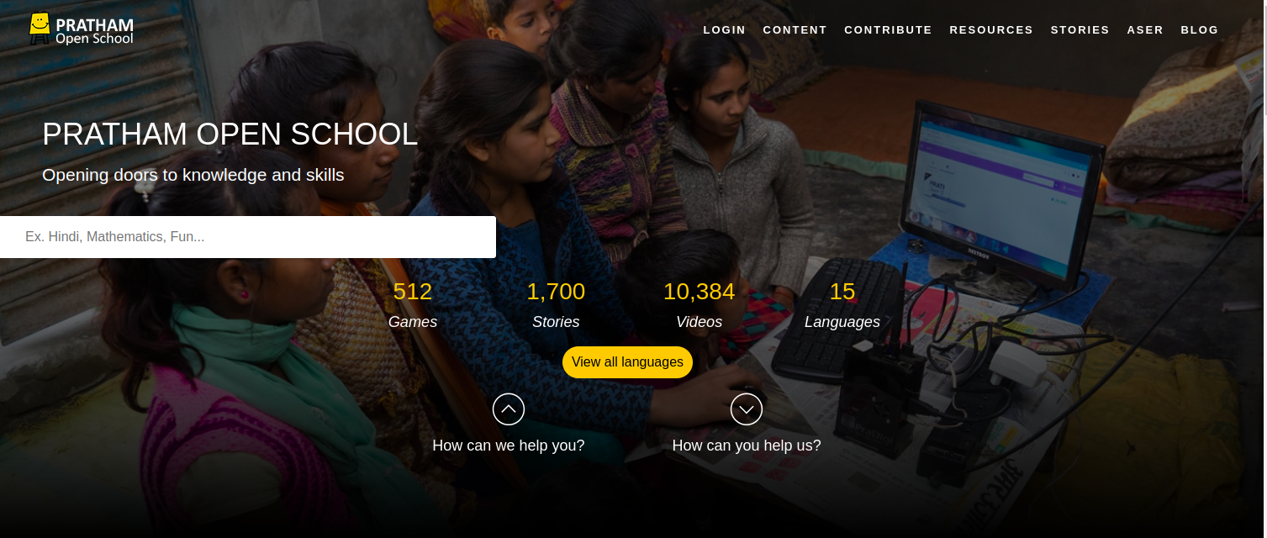

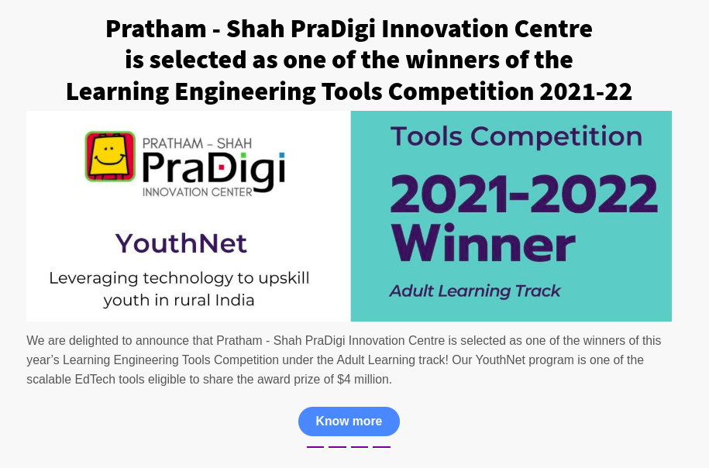

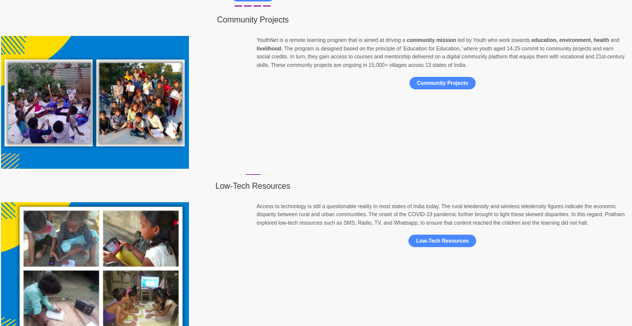

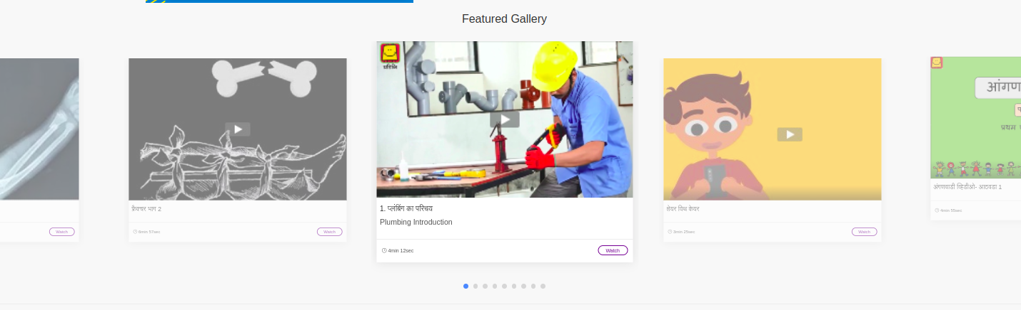

## Login Page:

* A google based signup/login.

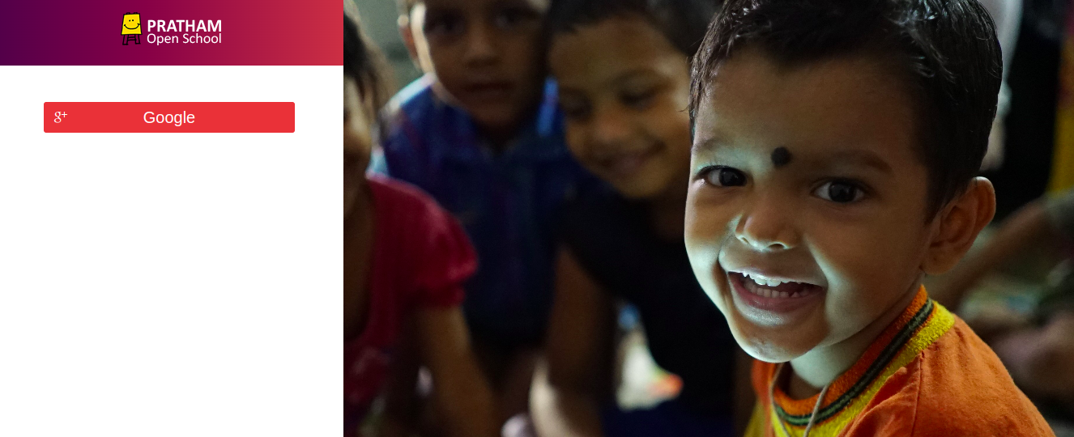

## Content

* A dropdown menu allows users to access content in multiple languages.
* The content is divided into four categories: Early Childhood Education, School Learning, Work Skills, and Lifelong Learning.

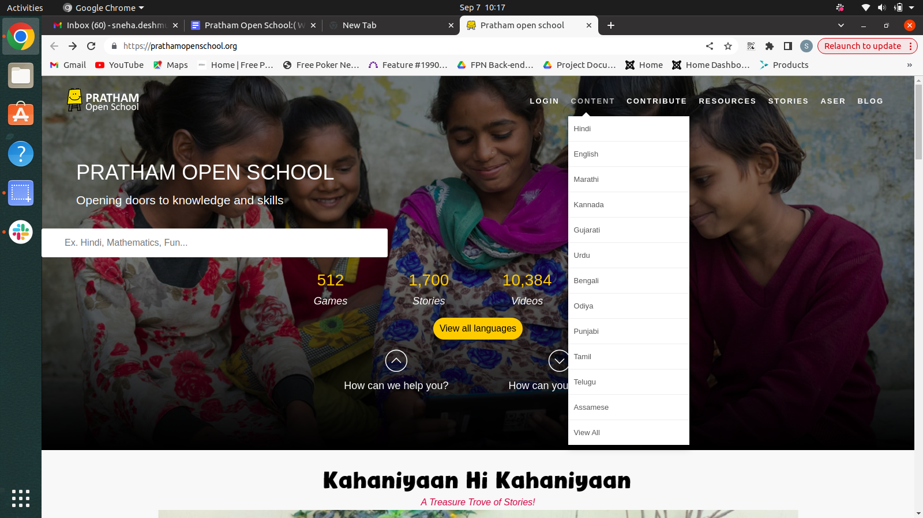

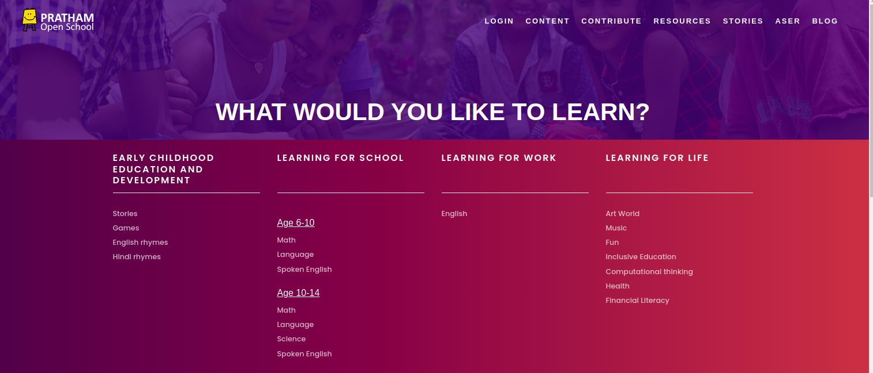

## Contribution:

* This page encourages people to join Pratham's mission of enhancing learning by harnessing digital devices available to us. Users can contribute in three ways: 1) sharing ideas, 2) providing resources, and 3) volunteering with us.

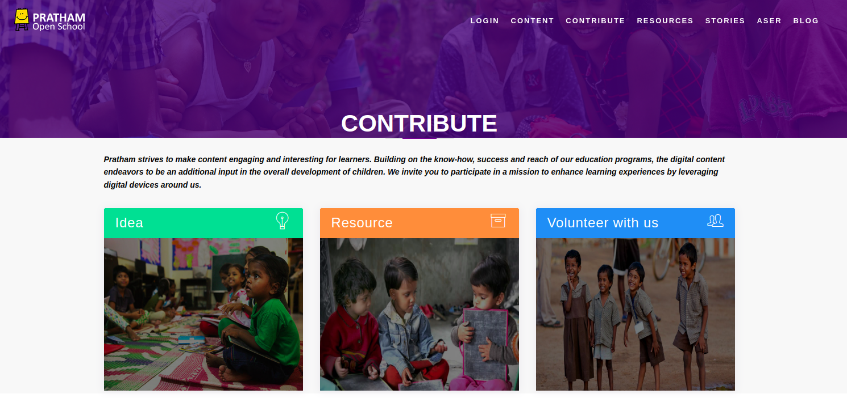

## Resource Section:

* Categorized into low-tech resources, COVID-19 information, and community projects.
* Low-tech resources provide comprehensive content.
* The COVID-19 section provides free resources related to COVID-19 protocols.
* Community projects showcase Pratham's initiatives to encourage user involvement**.**

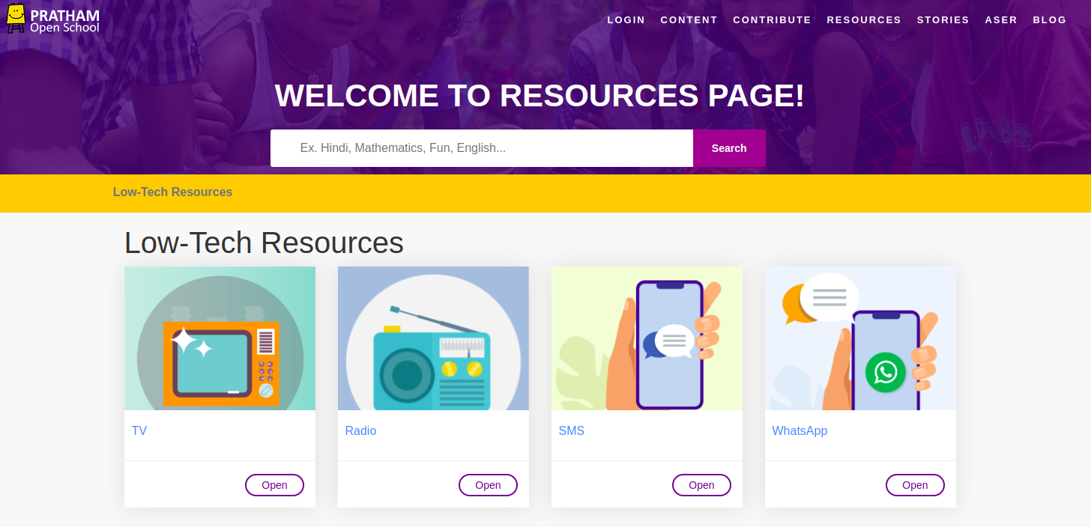

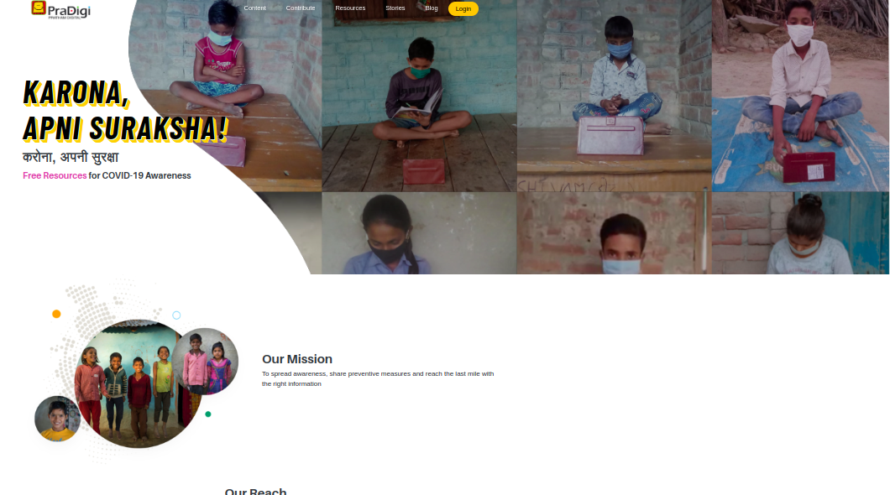

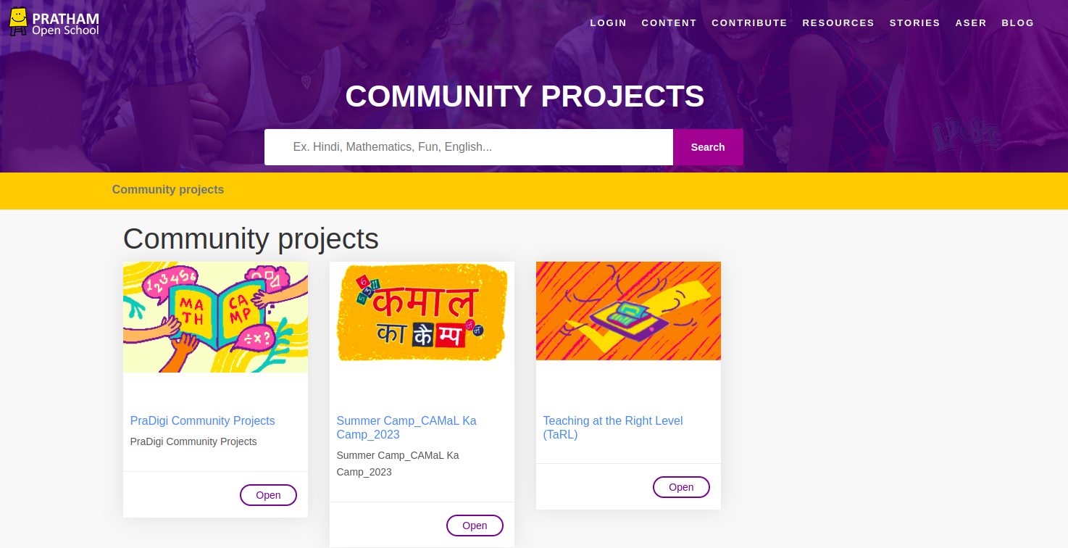

## Stories

* A section dedicated to video and audio-based stories for small age groups.
* Provides engaging story content to attract younger learners**.**

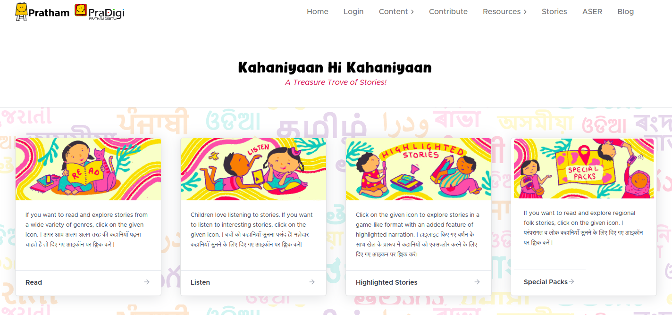

## ASER

* This section showcases videos related to theASER
* This section should have content categorised in 12 languages  
  Hindi, Marathi, English, Gujarati, Bengali, Urdu, Kannada, Odiya, Punjabi, Telugu, Tamil, Assamese.

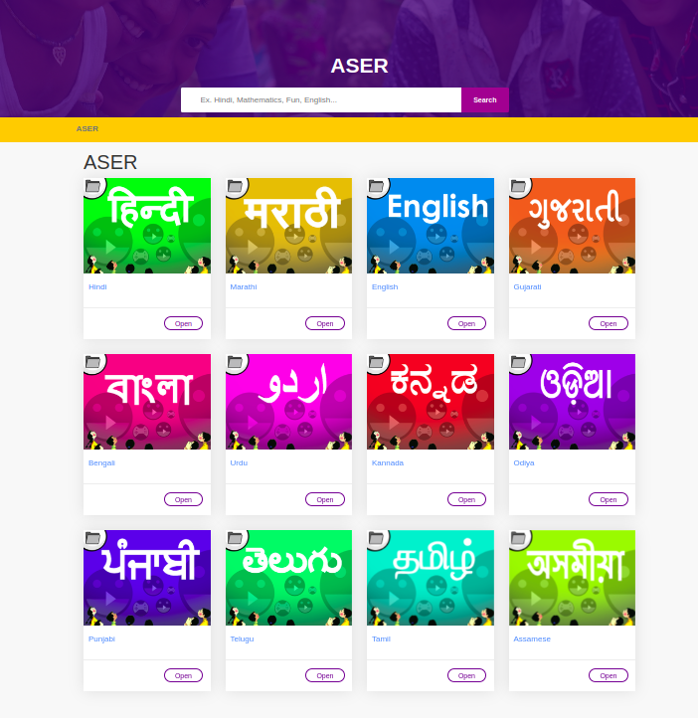

## Blog

* A dedicated blog section providing valuable insights into Pratham's activities and available resources.

